LEXINGTON X Shaped Dining Set

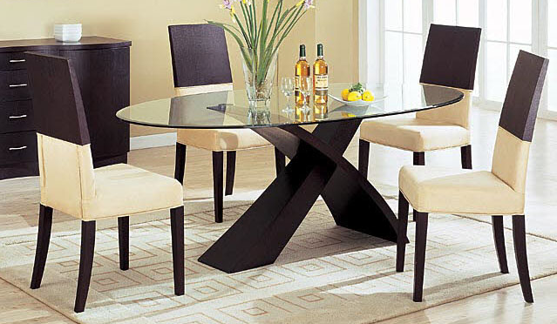

|  |
| --- |
| **DESCRIPTION** |
| LEXINGTON introduces stylish wooden glass dining set with a rich mirror gloss finish on top of the set of tables and chairs is perfect to create the perfect look out doors. The rich wood of the dine is perfect for humid conditions. Perfect for family night together and does not expand with change in temperature. |

|  |  |  |
| --- | --- | --- |
| **Price** | **1885$** | |
| **Dimensions** | **Table H** x **W** x **L** | **41in x 35.5in x 59in** |
| **Chairs H** x **W** x **L** | **30in x 16in x 20.5in** |
| **Features** | **Four Chairs and One Table with chemical glass sheet on top helps to maintain temperature by reflecting the heat and absorbing water droplets in the air.** | |
| **Finished** | **Round Cut Glass** | |
| **Available in** | **Brown and White Combo Only** | |